**DIGITAL MARKETING ASSIGNMENT**

**HASHTAG GENERATION**

1. **Identifying the buzzing area:**

The opted buzzing area is Customized Hoodie. Hoodies were a popular and versatile clothing item, and they have been in trend for several years prior. Hoodies are comfortable, functional, and come in various styles, making them a staple in many people's wardrobes, especially for casual and athleisure wear.

1. **Calculate Penetration Power:**
2. **Audience Size:**

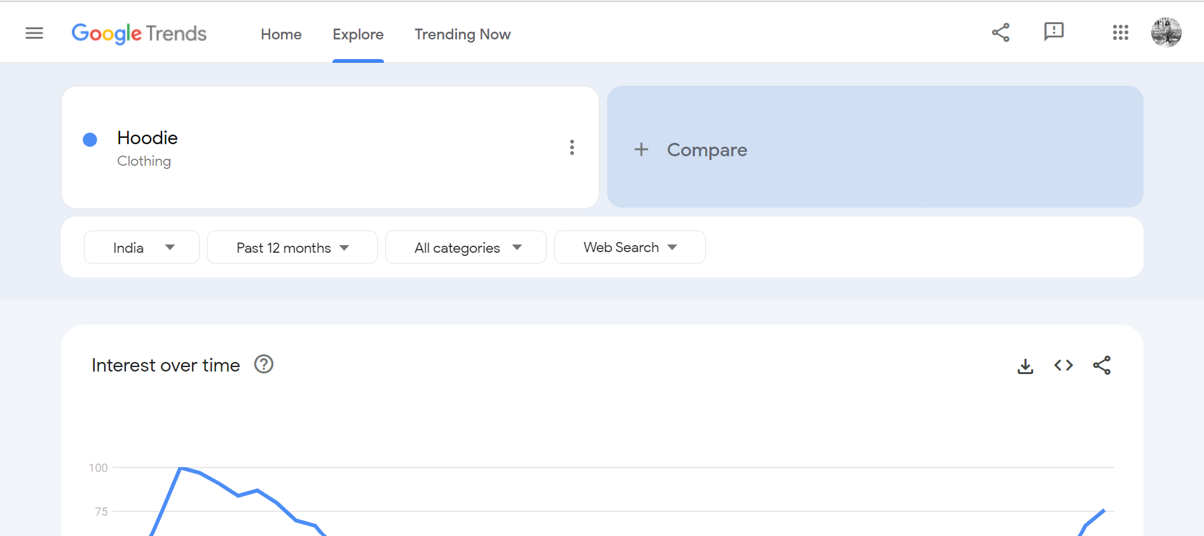

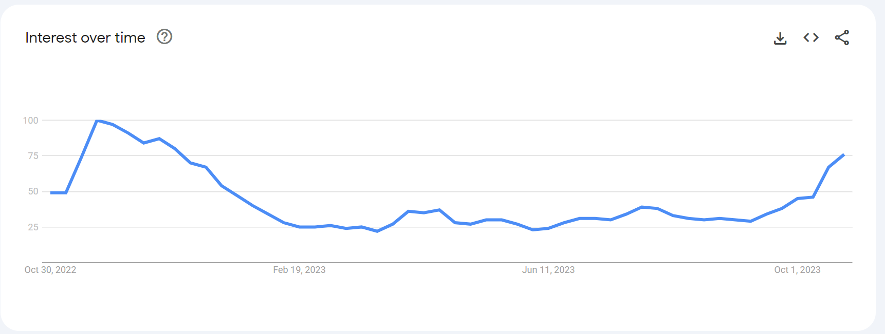

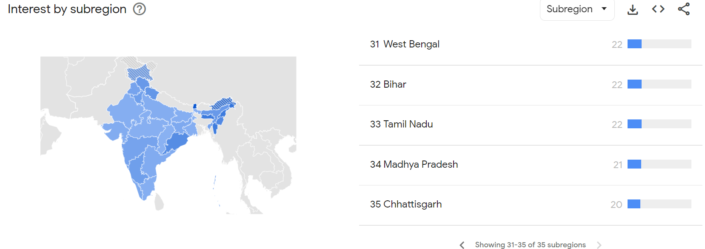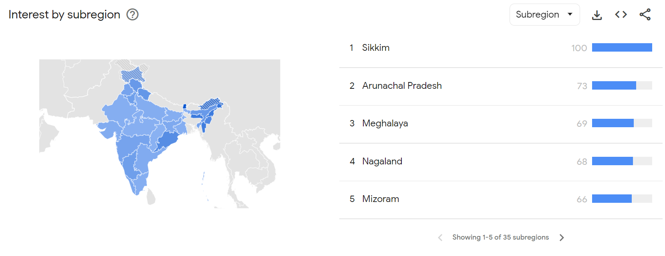

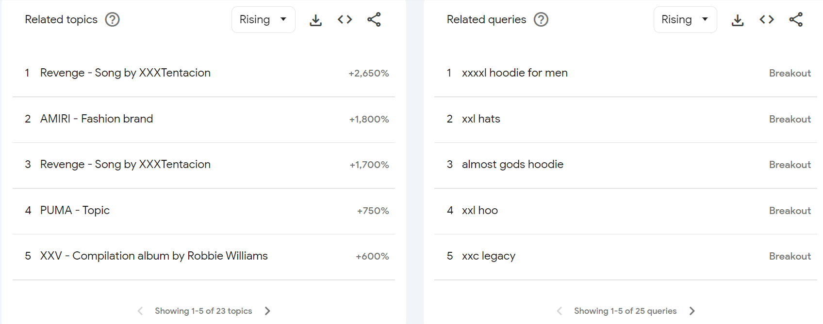

From Google trends data, we analysed that People from Sikkim shown high interest when compared to the other states in India while People from Tamilnadu shown less interest.

1. **Competitor Analysis:**

The.HustlersWadrobe is an Instagram page with 5855 followers which focuses on customization and printing of Hoodies.

From the analysis, That this page is not using hashtags in their posts which is an advantage for our page, Hoodiverse.

Hence, using the hashtags(#hoodiesforsale,#hoodiesSeason, #hoodiestyle, #hoodiesuprepremium, #hoodiesweater) people would easily reach out to our page.

1. **Influencer involvement:**

Master Sandy, Dancer and Ex Bigg Boss Tamil contestant from season 3 had become viral in the show with his famous line “we are the boys”. That famous line had been printed in his hoodies which influenced many to wear with printed texts in their hoodies. So choosing him would help us to reach many more audiences.

1. **Community Engagement:**

Single post per day would help to engage with our audiences. Also conducting Q&A sessions, offering gifts to our loyal customers help to bond with our audiences.

1. **Build Curiosity:**

In order to build curiosity, we made Instagram post with coming soon caption to unveil the 50% sale for our customers

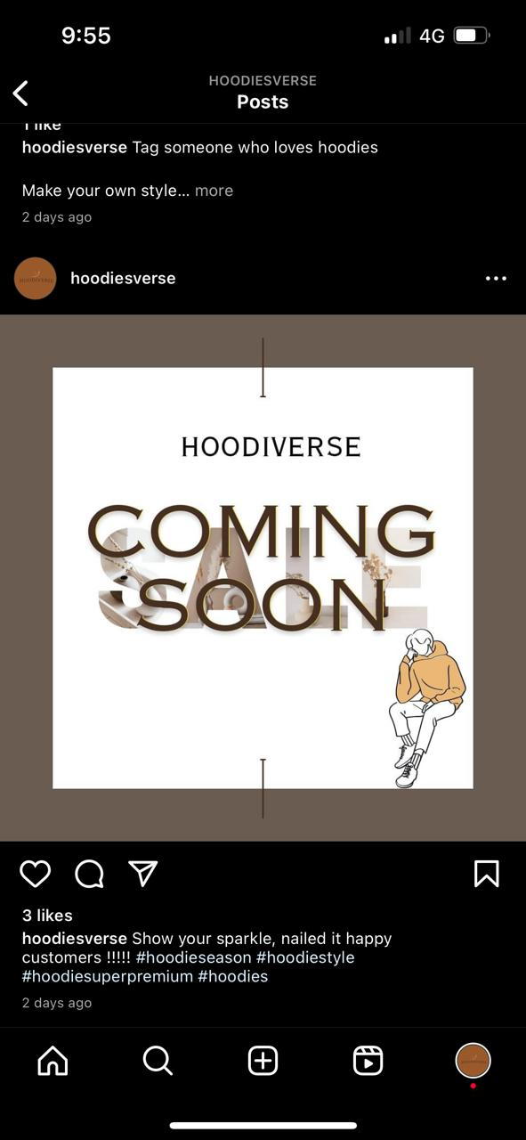

1. **Release Hashtags:**

#hoodiesforsale,#hoodiesSeason, #hoodiestyle, #hoodiesuprepremium, #hoodiesweater

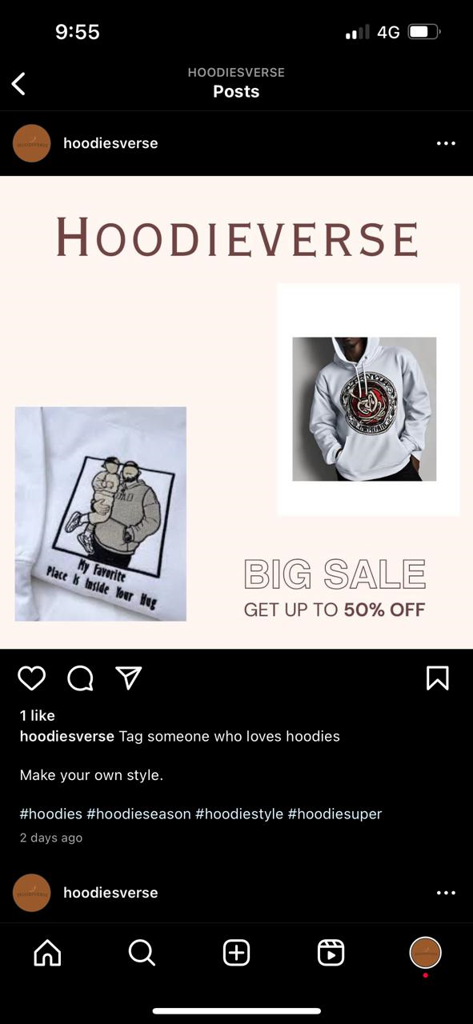

TEAM MEMBERS:

S Jogeashwini – NM Id-E60AA4B34E2BDDD995744164705B1A1B

Karthikeyan G- NM Id-36B8C4A8CD882ACBD9543357D60C74F1

Keerthi N G- NM Id- AF1B1467844E83EADDF46B27E2793DD9

From,

Department of Textile Technology

Alagappa College of Technology

Anna University,Chennai